

**Data Science Lab**

CSEL-42--

|  |
| --- |
| Assignment on Exploratory Data Analysis |

|  |  |  |
| --- | --- | --- |
| Submitted by | | |
|  |  |  |
| **NISHAT MAHMUD**  ID: B190305003 | **FAHIM HASAN**  ID: B190305029 | **MD. WALIUL ISLAM RAYHAN**  ID: B190305034 |

Submitted To

**MD. MANOWARUL ISLAM, PHD**

Associate Professor

Dept. of CSE

Jagannath University, Dhaka - 1100

Department of Computer Science and Engineering, Jagannath University, Dhaka

The Titanic dataset is a classic dataset widely used in data science and machine learning for exploring relationships between features and outcomes. It provides detailed information about passengers on the Titanic, including demographic details, travel class, and survival status.

The primary goal of this assignment is to perform Exploratory Data Analysis (EDA) to uncover meaningful insights about the dataset. In addition, data preprocessing steps are included to handle missing values and transform features to enable more effective analysis. Key visualizations such as histograms, bar plots, and heatmaps are used to highlight trends and correlations in the data.

This document provides a detailed explanation of each code section, ensuring a clear understanding of the EDA process and its findings.

This section imports all the necessary libraries for data processing, visualization, and modeling. %matplotlib inline ensures that plots are displayed directly within the Jupyter Notebook.

Loads the Titanic dataset from Seaborn’s built-in datasets.

Displays the first five rows of the dataset to preview its structure and contents.

Provides a concise summary of the dataset, including column data types and the presence of null values.

Displays statistical summaries such as mean, median, and standard deviation for numerical columns.

Counts the number of missing values in each column to identify issues with incomplete data.

Fills missing values in the 'age' column with the median value using the SimpleImputer. Also, replaces missing values in 'embarked' and 'embark_town' columns with the most frequently occurring value.

Drops the 'deck' column because it contains too many missing values, making it unreliable for analysis.

Removes rows with missing values in the 'alive' column to maintain consistency.

Creates a new feature 'family_size' by summing the number of siblings/spouses ('sibsp') and parents/children ('parch') on board, adding 1 for the passenger.

Encodes the 'sex' column into numeric values (0 for female, 1 for male) using label encoding.

Performs one-hot encoding on categorical columns to convert them into numerical format, dropping the first category to avoid redundancy.

Standardizes the 'age' and 'fare' columns to have a mean of 0 and a standard deviation of 1, improving model performance.

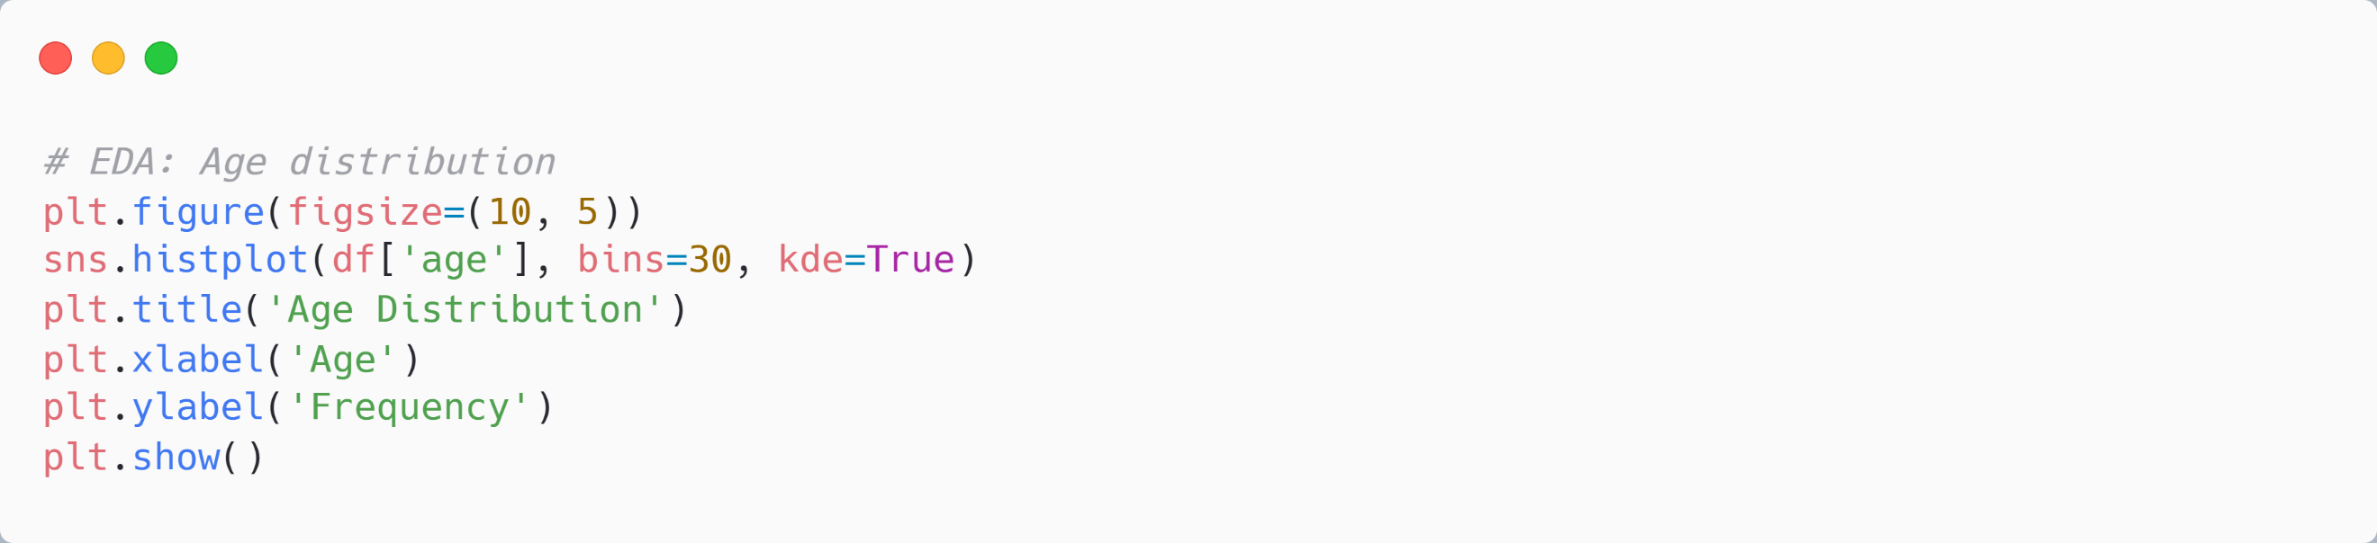

Plots the distribution of 'age' using a histogram with a kernel density estimate (KDE) curve to visualize the spread of ages in the dataset.

Plots the distribution of 'fare' to examine its spread and detect potential outliers.

Creates a bar plot to show survival rates for different genders.

Visualizes survival rates by passenger class to observe how class influenced survival.

Displays a heatmap to visualize the correlation between features in the dataset.

Uses a box plot to detect outliers in the 'fare' column, categorized by survival status.

Separates features (X) and target variable (y) for logistic regression.

Splits the dataset into training (70%) and testing (30%) sets for model evaluation.

Initializes and trains a logistic regression model with a maximum of 1000 iterations for convergence.

Uses the trained model to predict survival outcomes for the test set.

Evaluates model performance using accuracy, a classification report, and a confusion matrix.

Through the Exploratory Data Analysis (EDA) of the Titanic dataset, we uncovered valuable insights about survival rates and their relationship with features such as age, gender, fare, and passenger class.

The analysis also showcased the importance of data preprocessing, including handling missing values and feature engineering, to enable accurate and meaningful exploration. These insights can serve as a foundation for further predictive modeling or decision-making.